
Company
Logotype

Cone Beam Computed Tomography- Report



Porur Dental X-rays & CBCT

Patient Name : Mrs. Padmavathy | Date of Report : 02.07.2024
Age/ Gender : 64 years/ Female | Region of Interest : CBCT Full Skull
Referring doctor: Dr. Balamurali Sai | Indication : To rule out Periapical lesion ?
Clinical Notes: Nil
PATIENT INFORMATION

CBCT- Full Skull provided
CBCT – IMAGE DETAILS

RADIOGRAPHIC INTERPRETATION

- Presence of hyperdense crown structures in relation to 13, 14, 15, 16, 23, 24, 25, 26, 27.
- Root stumps 38; Impacted tooth: 28.
- In relation to the periapical aspect of 15, 16, 17 widening of periodontal ligament space and presence of diffuse areas of hypodensity involving the alveolar bone is evident.
- Degenerative changes present in relation to the periapical aspect of 16 causing discontinuity of the floor of the maxillary sinus is evident.
- The apical portion of 16- palatal root is present with hyper cementosis, and the hypodense area appears to cause extreme thinning of the buccal and palatal cortical bone.
- In relation to 11, 12, 13, 21, 22 presence of hyperdense restorative material involving the pulp canals extending upto the apical third of the roots is evident.
- Complete hyperdense opacification of the right maxillary sinus, obliteration of the osteomeatal complex is evident.

RADIOGRAPHIC IMPRESSION

- Chronic periodontitis and periapical pathology in relation to 13, 15, 16, 17.
- Oro antral communication in relation to 16 region.
- Root canal treated teeth: 11, 12, 13, 21, 22.
- Root stumps 38; Impacted tooth: 28.

Kindly correlate with clinical findings


IMAGES FOR REFERENCE

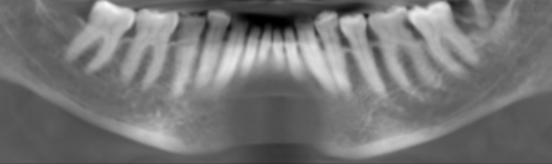
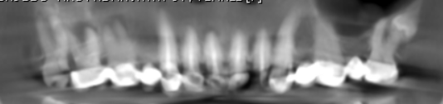
RECONSTRUCTED PANORAMIC VIEW

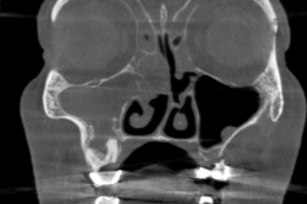
Complete hyperdense opacification of the right maxillary sinus, obliteration of the osteomeatal complex is evident.

3-DIMENSIONAL VIEW

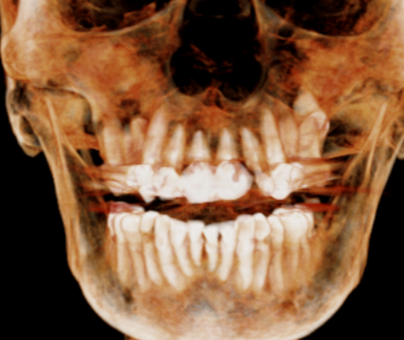

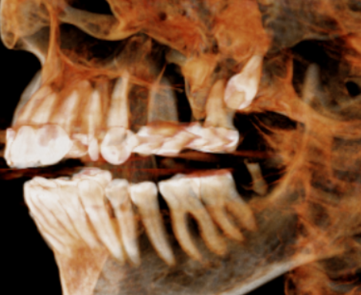
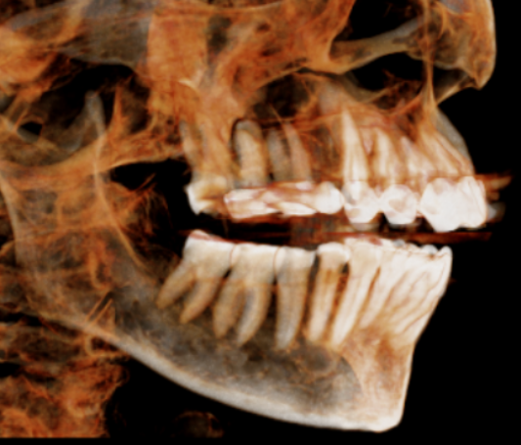

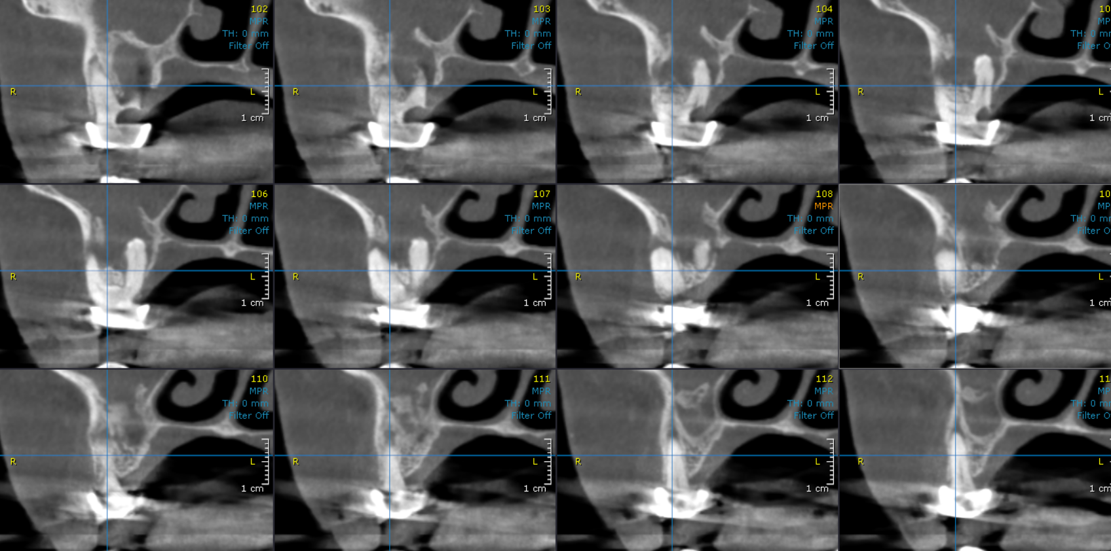
CROSS SECTIONAL VIEW

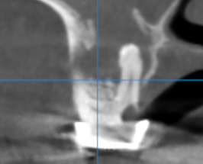
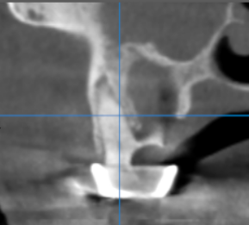
Hypercementosis

Oro antral communication

Thinning of palatal bone

**** End of report ****

